RESUME
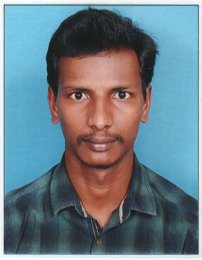

AKKENAPALLI SANTHU
H.No.4-89,
Anajipuram,Penpahad Mandal ,
Suryapet District, Mobile: 9642983268 Telangana-508213 Email-Id: santhua306@gmail.com

OBJECTIVE:

- To succeed in an environment of growth and excellence and earn a job which provides me job Satisfaction and self development and help me achieve personal as well as organization goals.
.

EDUCATIONAL QUALIFICATIONS:

Qualification | Institution/College/School | Percentage | Year of Passing
B.Com (Computers) | Spandana Degree College , Suryapet | 66.66 % | 2017
Intermediate (CEC) | Pragathi Junior College , Suryapet | 76.50 % | 2014
10th Class  (SSC) | ZPHS High School , Anajipuram | 7.5 GPA | 2012

TECHNICAL SKILLS:

- Tallay
- MS-Office
STRENGTHS:

- Hard Work
- Good Learning Ability
- Political Awarness

PERSONAL DETAILS:

Candidate Name : Akkenapalli Santhu
Father Name : Balaiah
Gender : Male.
Date of Birth : 14-06-1997
Martial Status : Unmarried
Nationality : Indian.
Languages Known : Telugu and English.

DECLARATION:

I do here by declare that the above mention my statements are true to the best of my knowledge and belief.

Place :

Date : (Akkenapalli Santhu)

